ShopHub

___________________________________________

Website Documentation

Trader Guide

___________________________________________

Student Name: Nischal Aryal

Student ID: 77261069

Module Name: Production Project

* Inserting login credentials allow Traders to login to the Dashboard

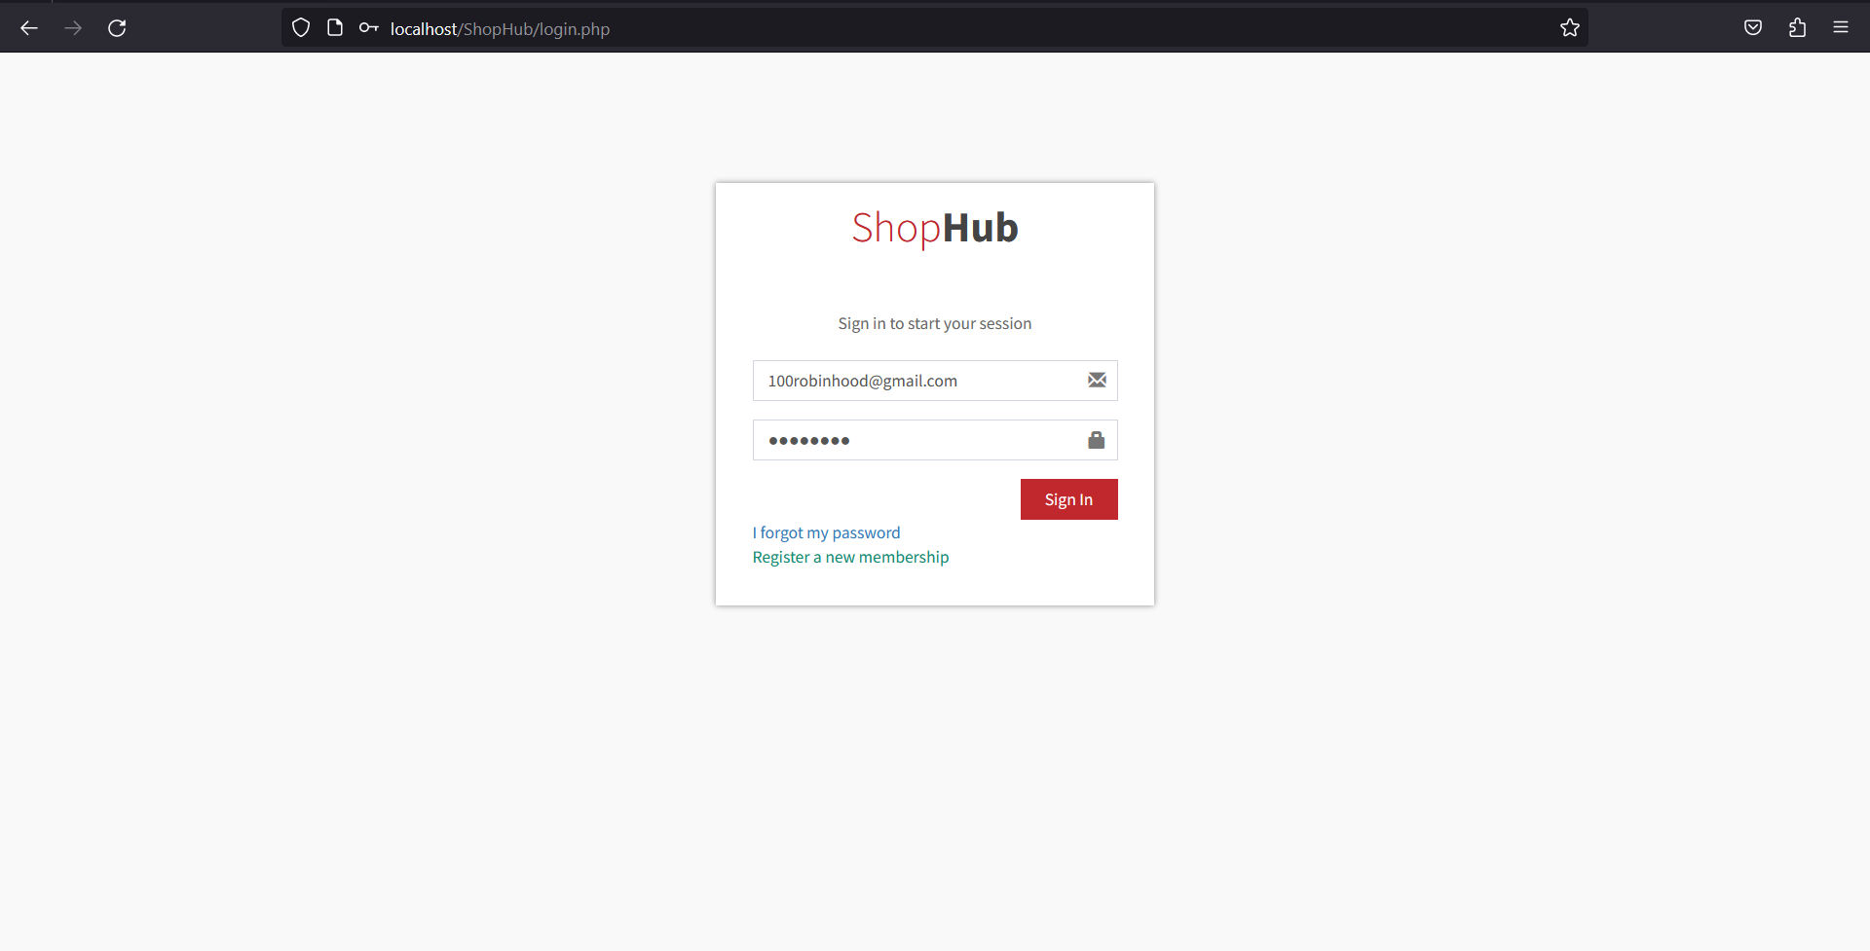

* Trader first need to finish setting up their trader account before being able to add their shops and products.

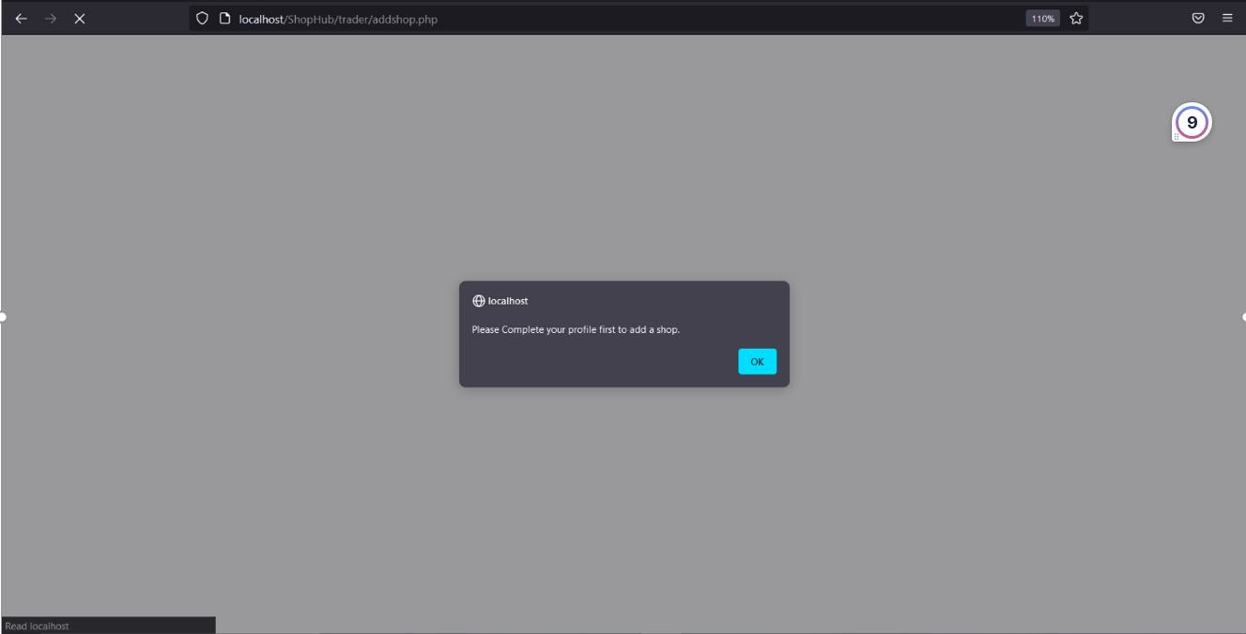

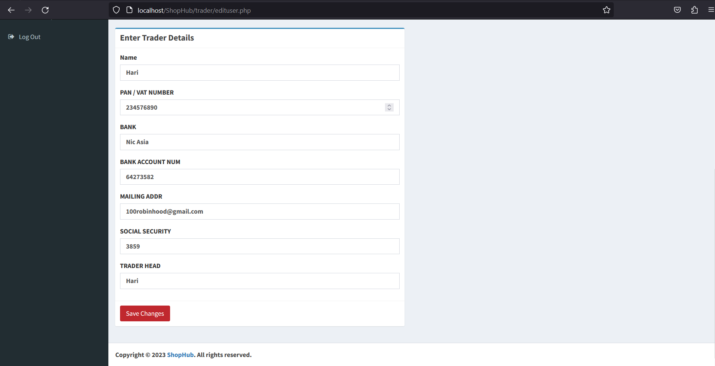

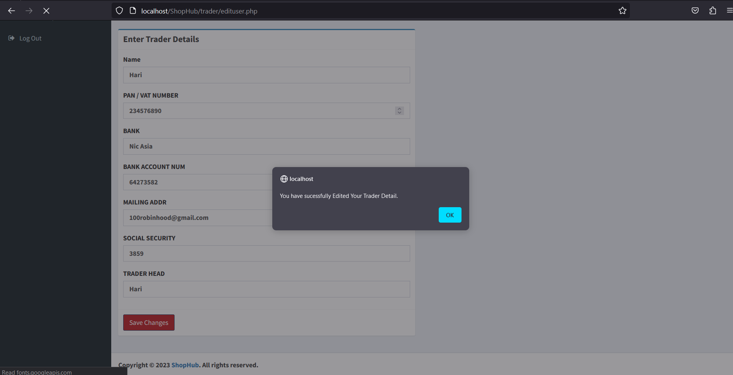

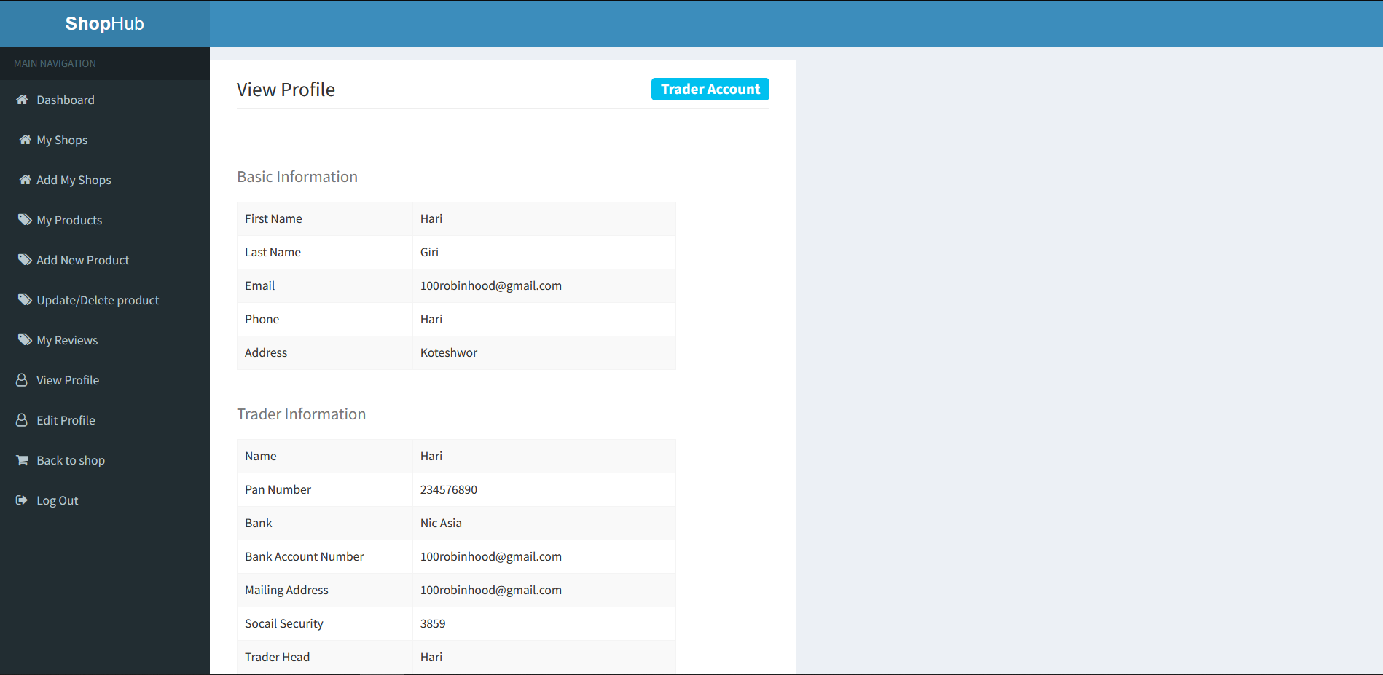

* Trader can now add their shops.

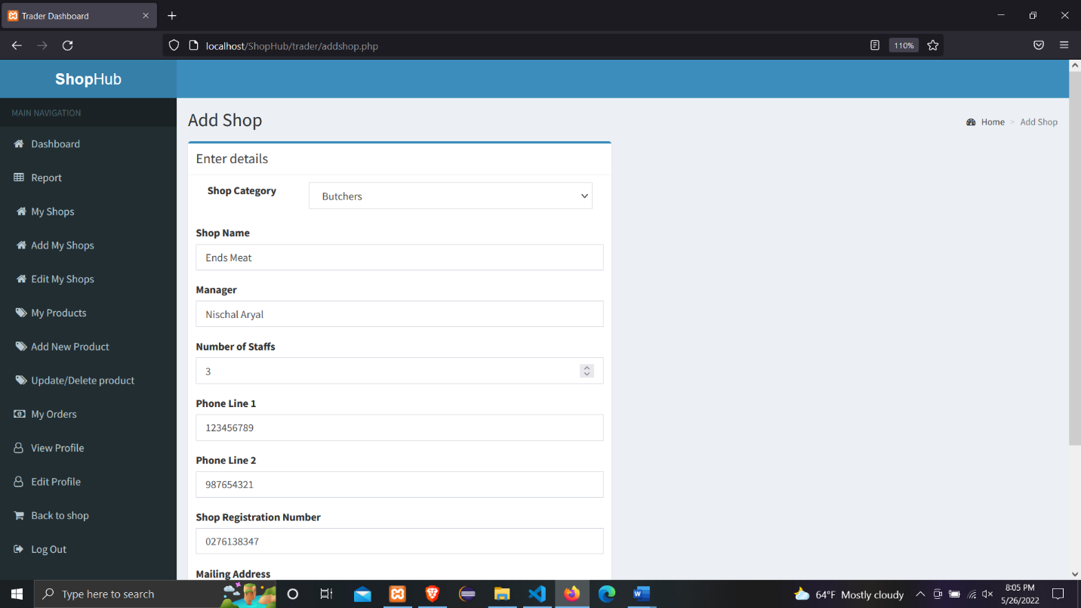

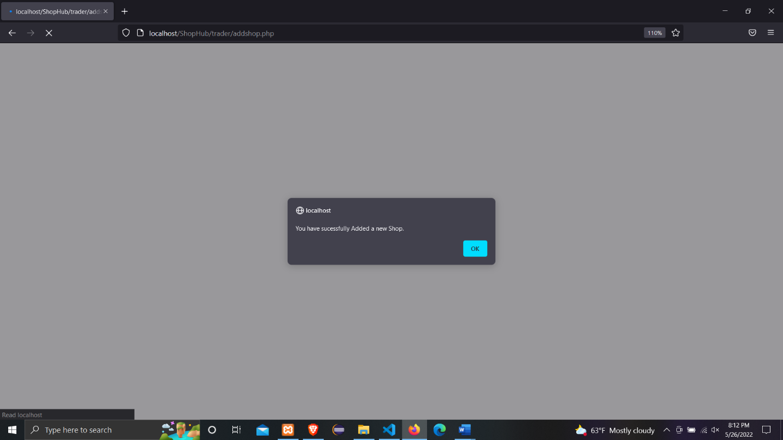

* After the shop is activated by the admin trader can add products to their shops.

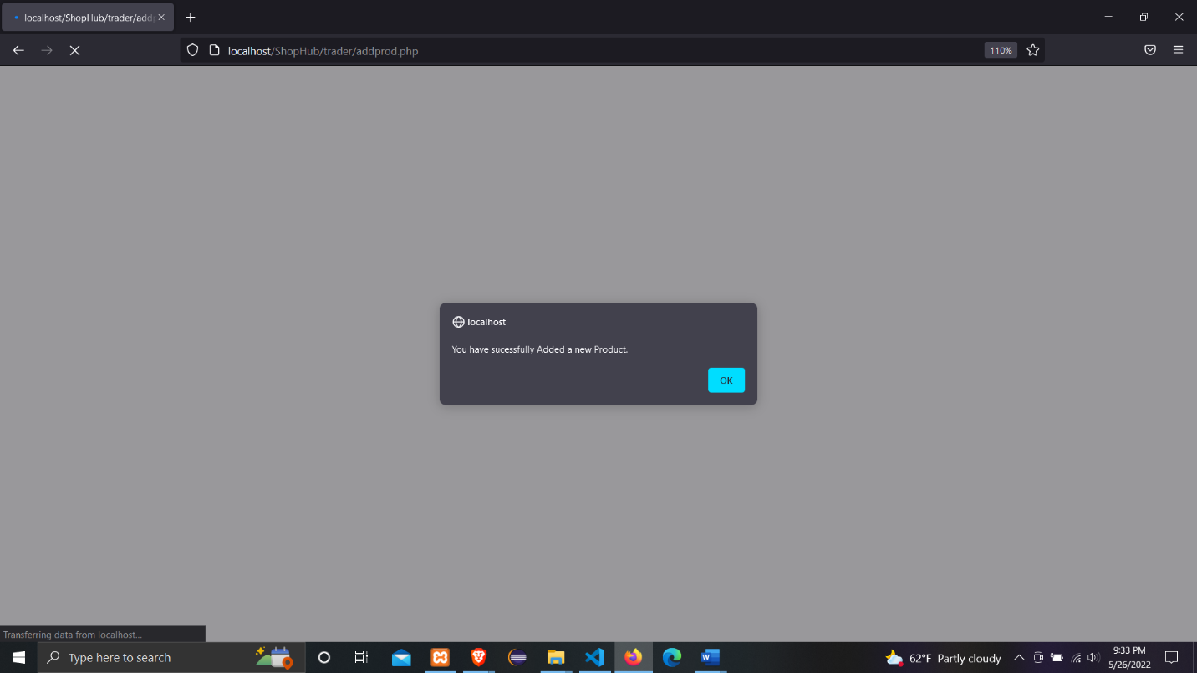

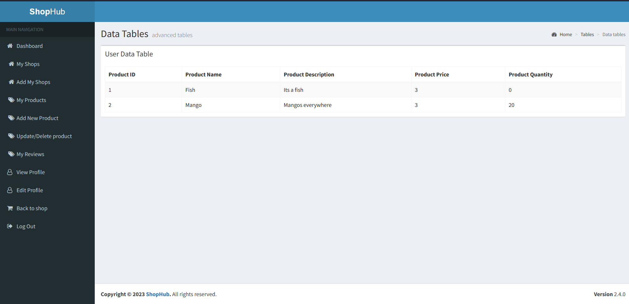

* Trader are able to view their shops as well as their out of stock products and their products reviews from their Dashboard.

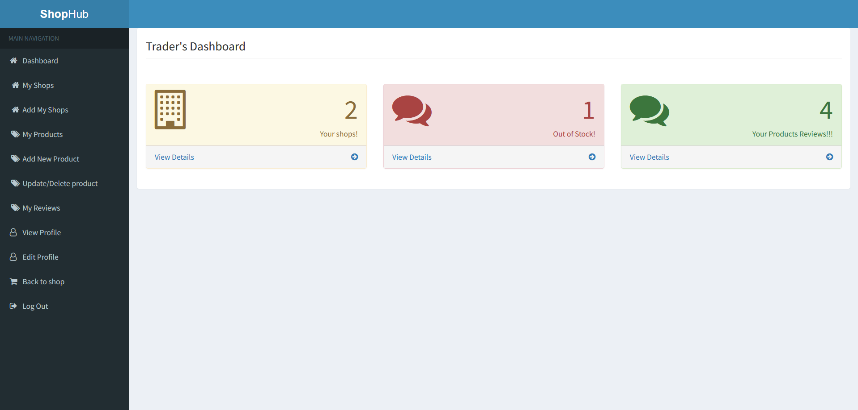

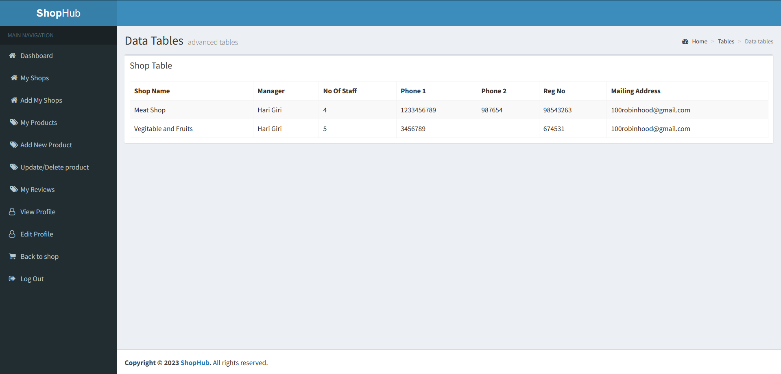

Fig: Trader’s Shop Details

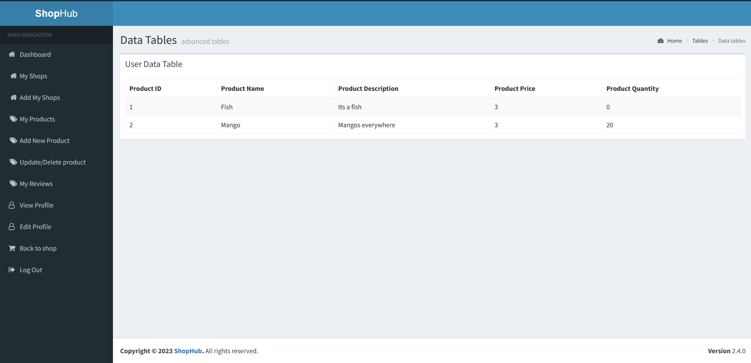

Fig: Trader’s Out of Stock Product

* Trader can view their product review and their corresponding sentiment that is predicted by a pre-trained sentiment analysis model

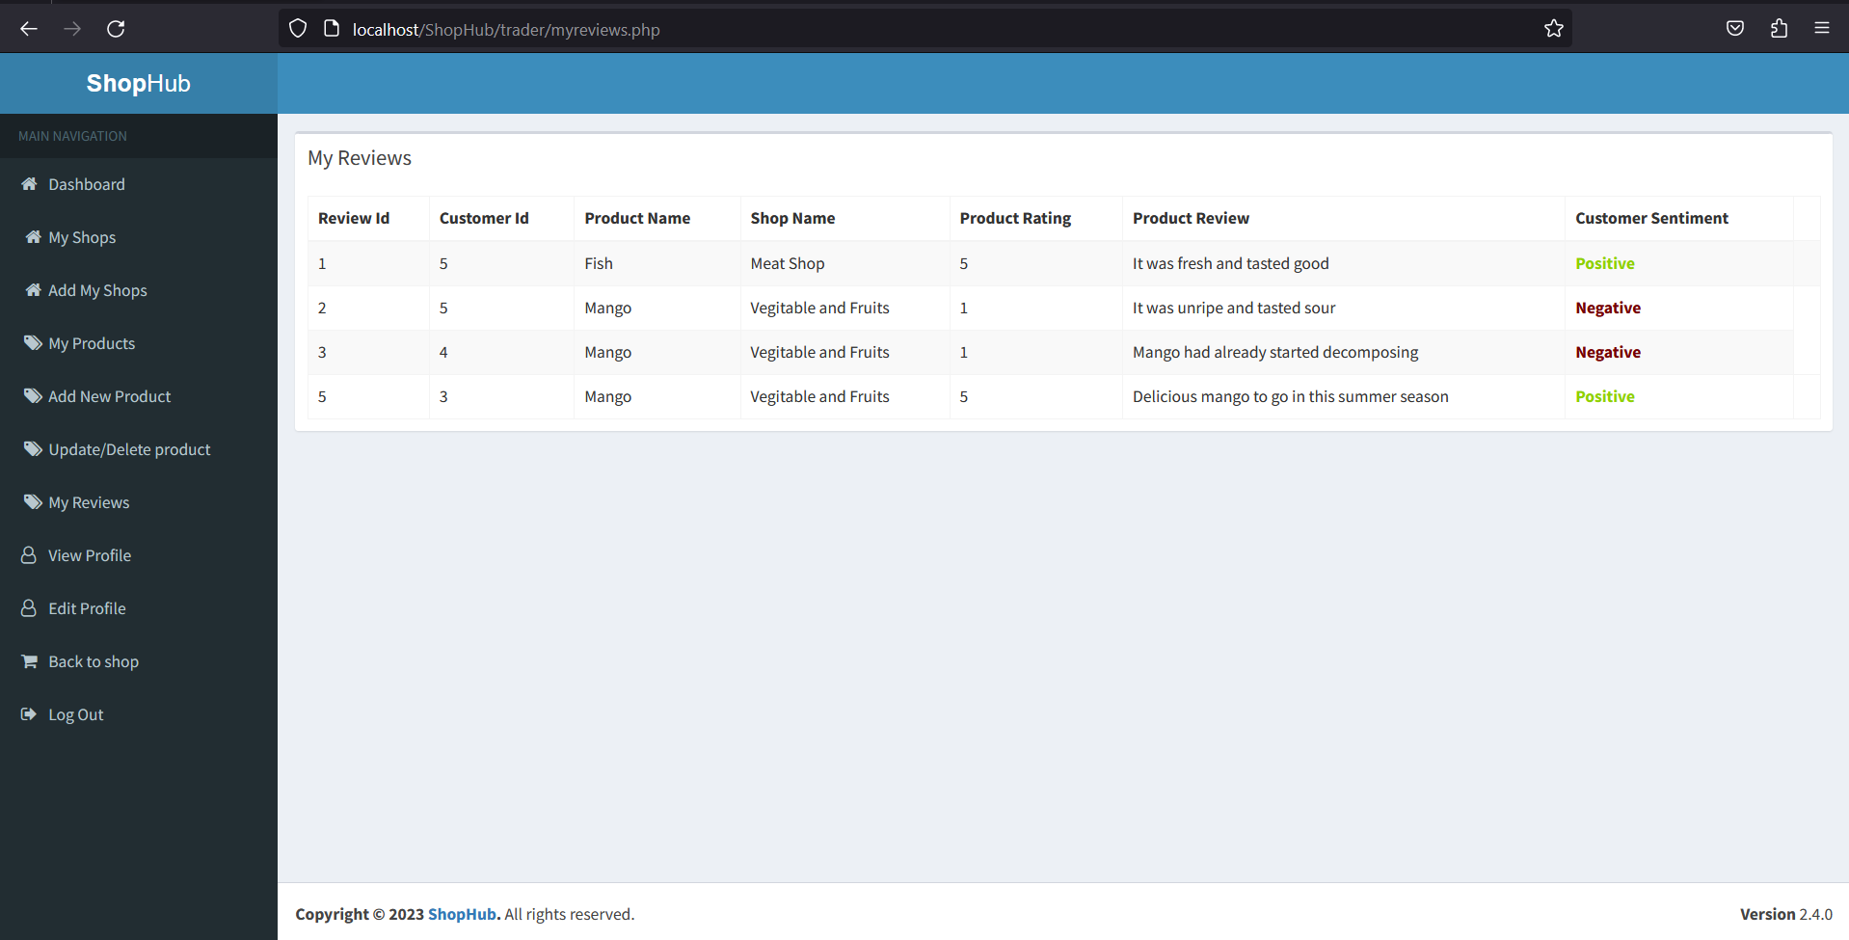

* Trader can manage their profile

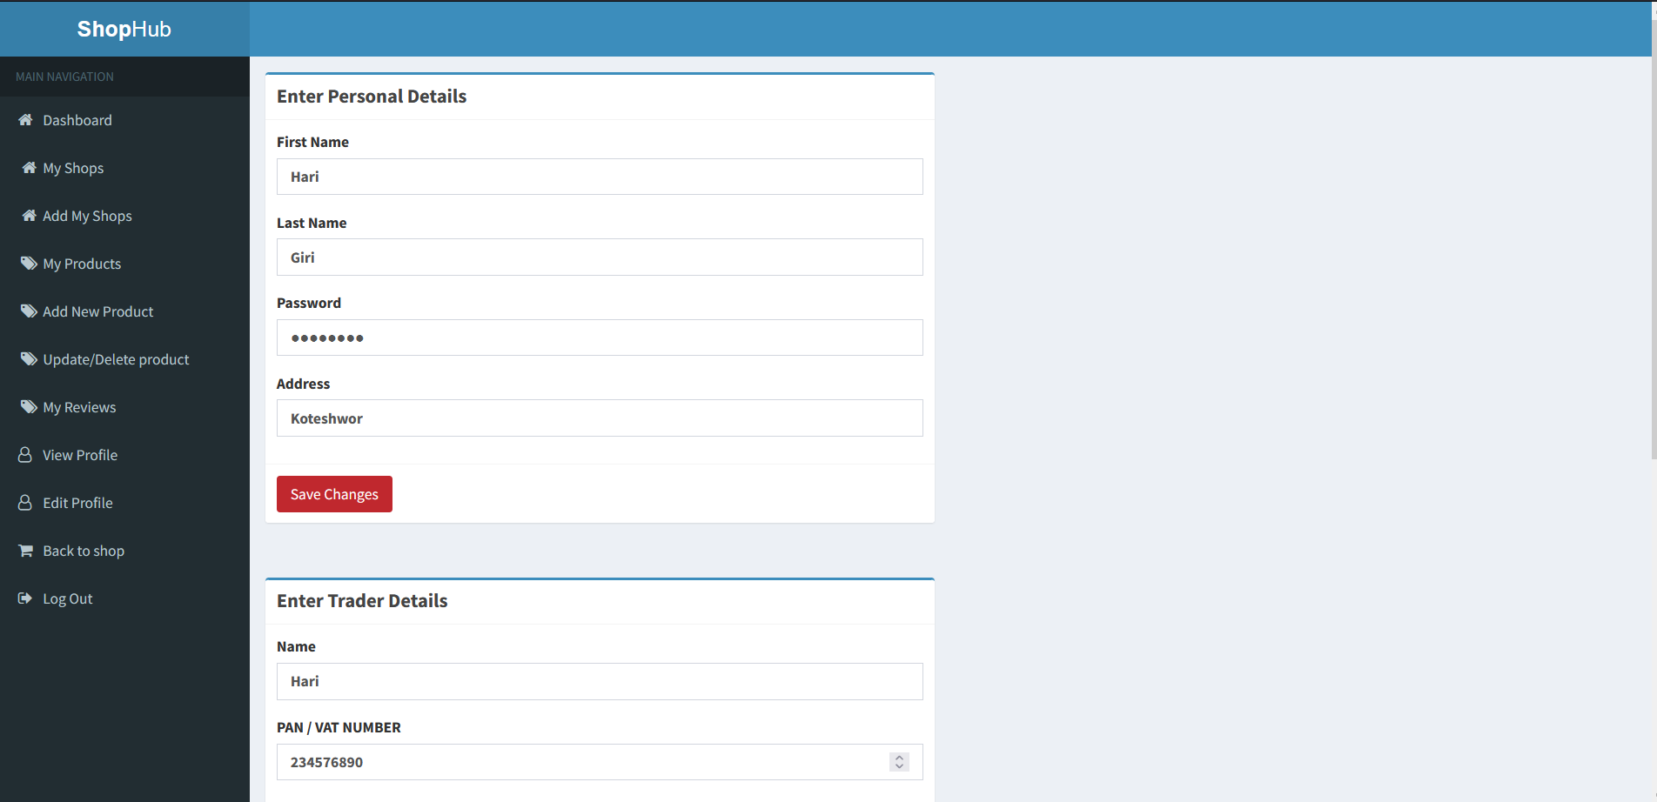

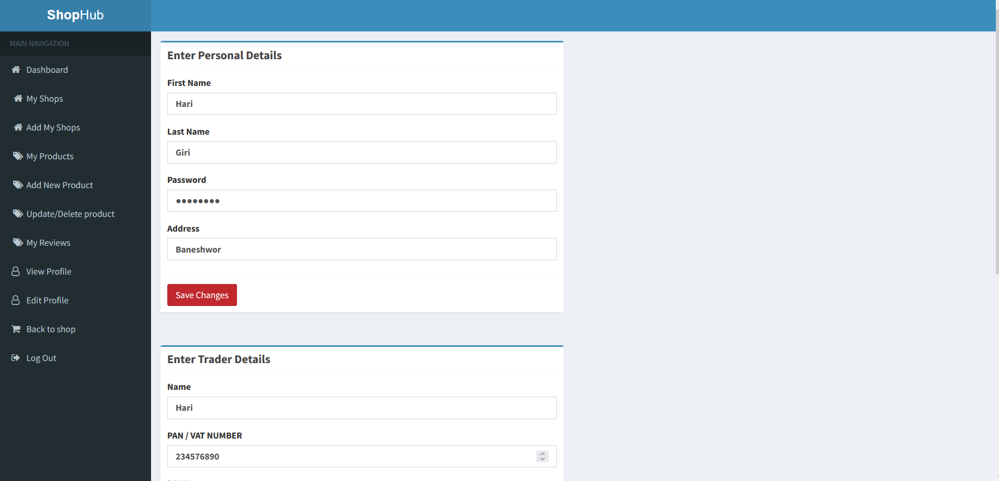

Fig: Changed Address previously Koteshwor now Baneshwor

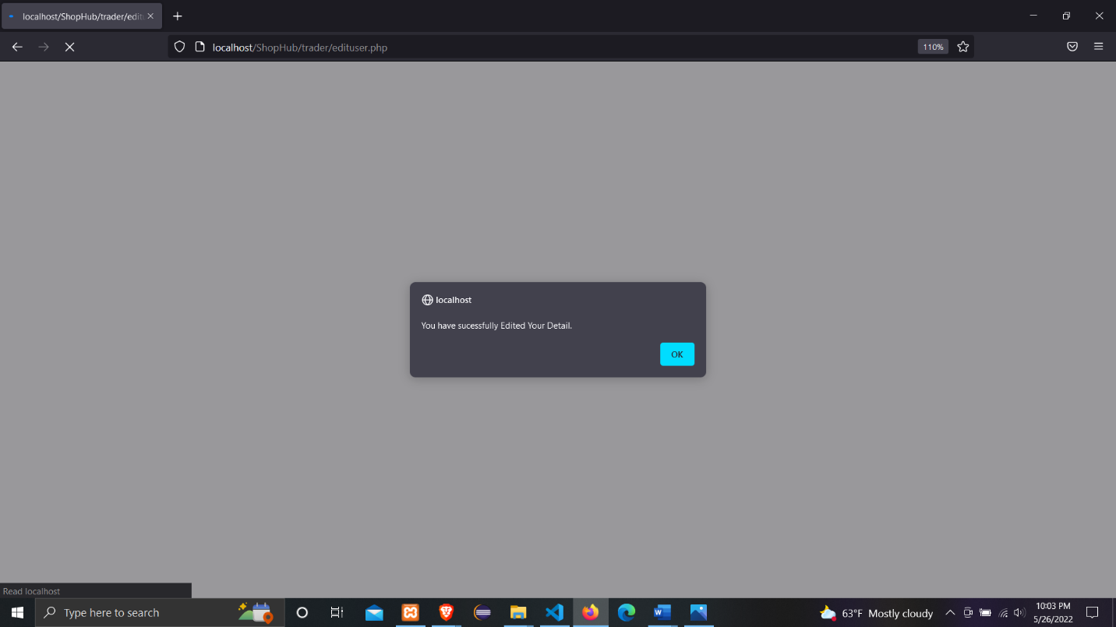

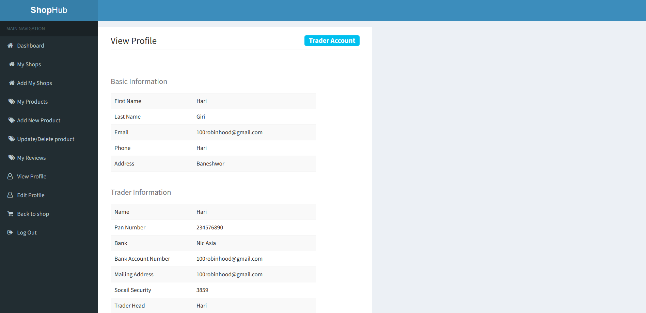

* Trader can add their Shops

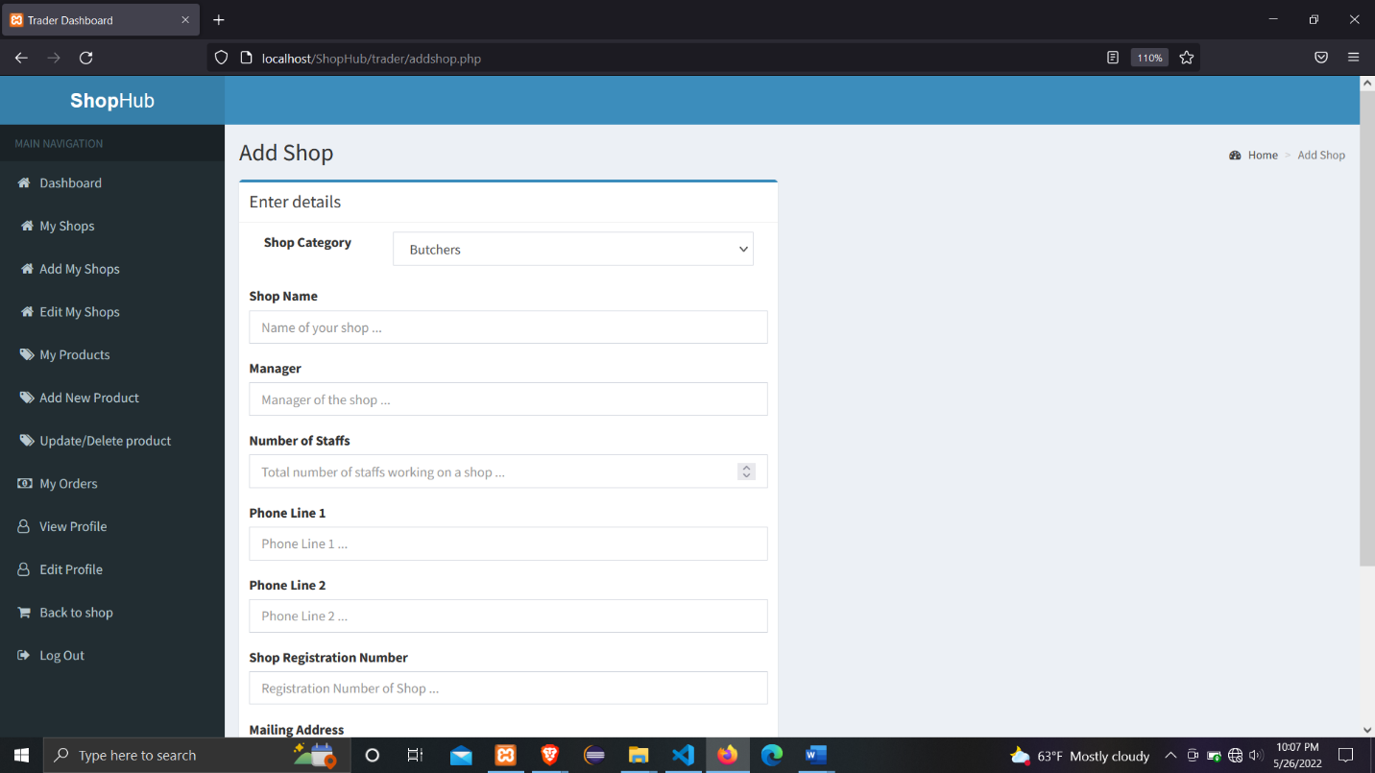

* Trader can perform CRUD operations on their products

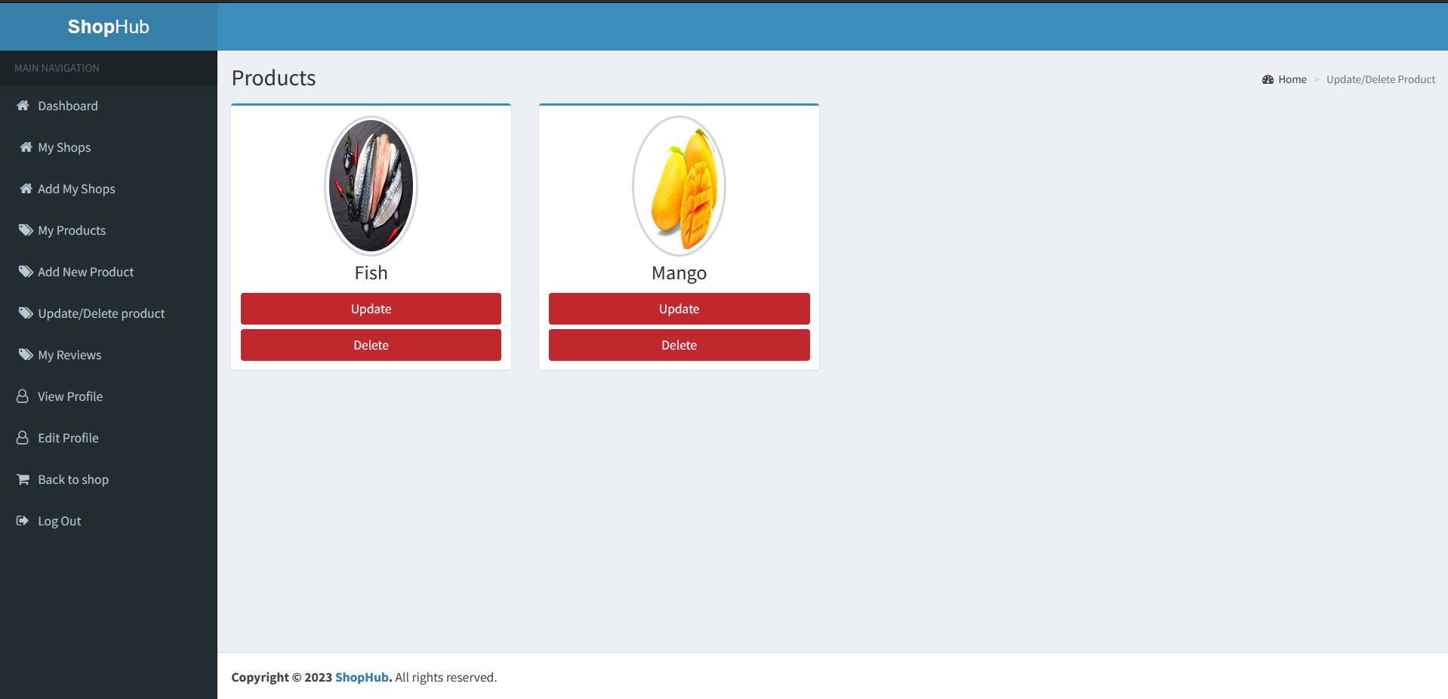

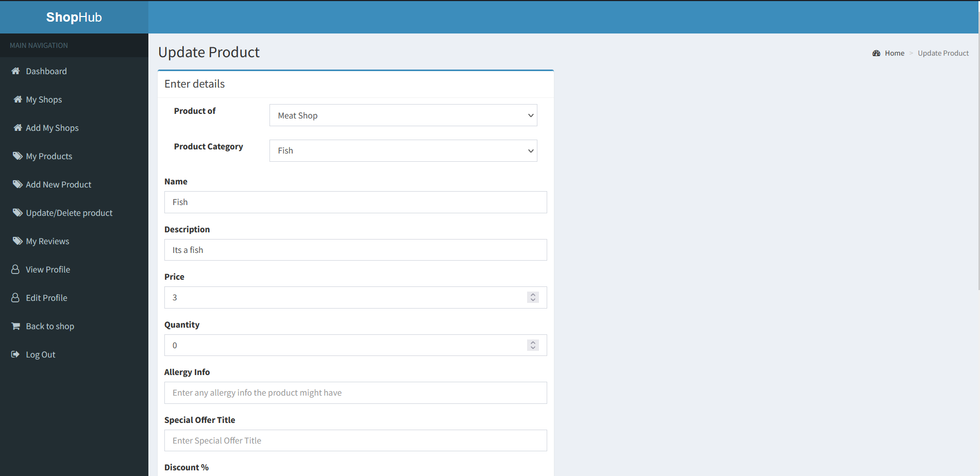

* Traders can go back to the shop and inspect the newly made changes to their shops, and products.

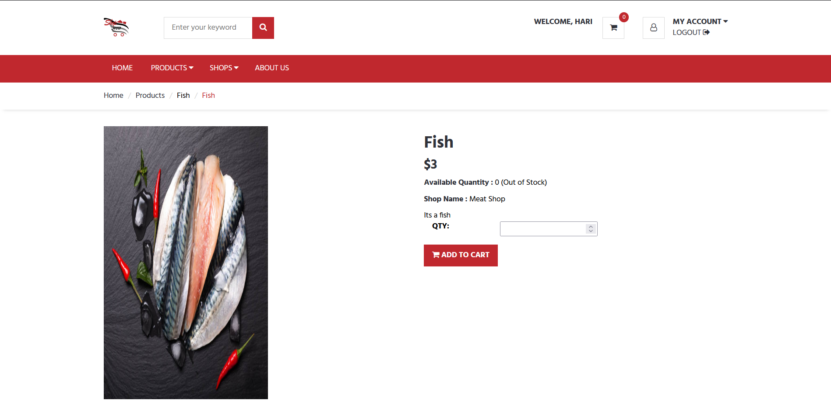

* Traders can log out of their account after they have used the site.

